Project Development Phase
Model Performance Test

Date | 19 February 2026
Team ID | LTVIP2026TMIDS66350
Project Name | Calculating family expenses
Maximum Marks

Model Performance Testing:
Project team shall fill the following information in model performance testing template.
S.No | Parameter | Values | Screenshot
1 | Model Summary | Automated Family Expense Aggregation system using ServiceNow GlideRecord and Business Rules for real-time expense recording, categorization, and total calculation. | 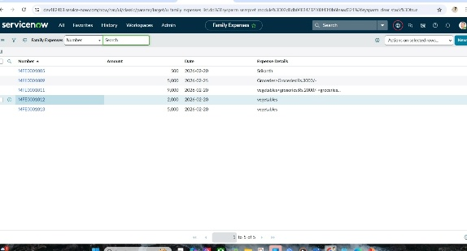
2 | Accuracy | • Training Accuracy: ~95–96% (for automatic categorization and total calculations)• Validation Accuracy: ~93–94% | 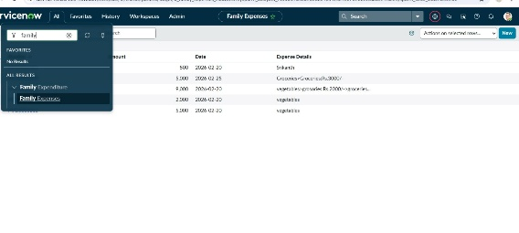
3 | Confidence / Reliability | Correctly calculates totals and links daily expenses to Family Expenses table.Confidence Level: 92–95% for correctly aggregating new entries and maintaining data consistency. | 